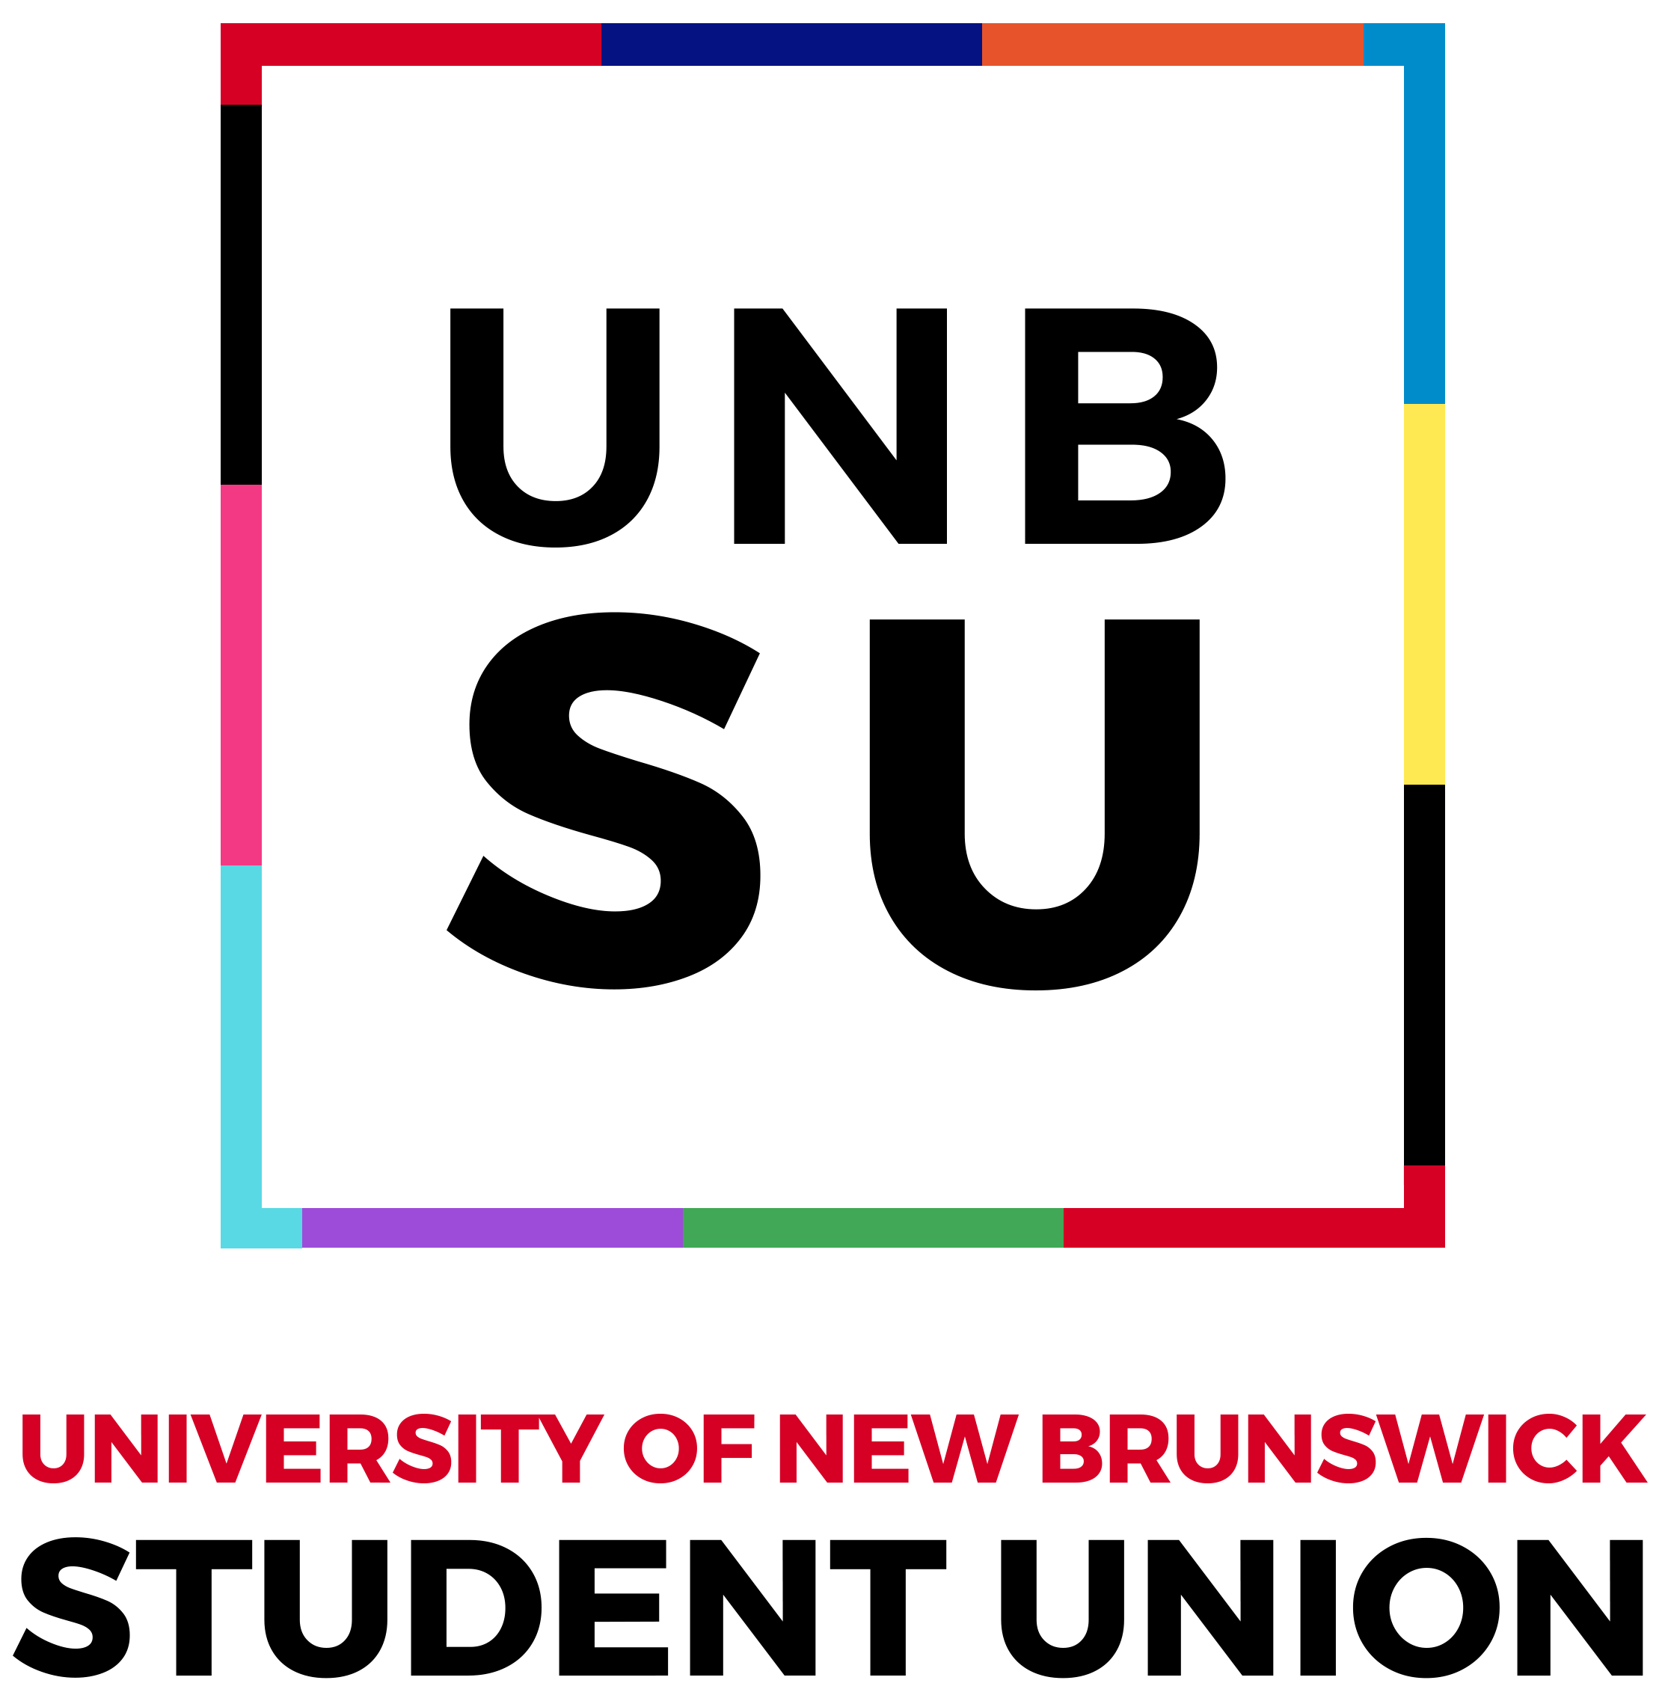
UNB Student Union | Hiring

Position: RedShirt Orientation Volunteer
Deadline: May 12th, 2024
Duration of position: August 2024 – September 2024
Reports to: Orientation Chair and Vice-Chair

Requirements:
- Preference will be given to full-time, undergraduate UNB-F students, however UNB-F part-time and/or graduate students will be considered.
- The applicant must be in good academic standing as determined by the office of the Student Engagement Coordinator.
- Must attend RedShirt training sessions (August 28th to 30th) and Orientation Week (August 31st to September 8th).
- Must be endorsed by a member of the University community who is not a fellow student. Acceptable individuals include a residence life coordinator,, professor, coach, advisor, or other individual approved by the Orientation Chair. If a student/prospective RedShirt is going to live in residence and receives an endorsement from another individual, their RLC must also give approval for them to return to campus early for RedShirt training and Orientation Week.
- Must submit a completed application form, sign a conduct contract applicable during training and orientation week, and pay the requisite volunteer fee.

Duties:
- An Orientation Leader.
- Helping to welcome new students.
- Acting as a role model.
- Part of the students first impression of UNB, therefore a representative of UNB, the UNBSU, and the Fredericton community.
- Orientation is a substance-free program – so all RedShirts are expected to abstain from substance use during training and orientation and uphold the expectations with our students.
- Being positive and energetic, friendly and professional.
- Facilitating event duties: set up, event running, supporting students, tear down.
- RedShirts are the foundation of Orientation
- Additional Crew Duties if you sign up for a crew (Media Crew, Rowdy Crew, Sustainability Crew, etc).

Qualifications:
- Strong organisational and interpersonal skills
- Enthusiastic and approachable
- Open-minded and creative

To apply for RedShirt, please fill out our type form here:
https://forms.office.com/Pages/ResponsePage.aspx?id=0m5OJJoz80e5XORTUcGYt4TVWKVtZ1pLogRiCxdFjoxUNkRLWlZaOFRPODdOTUJaNFU2RU4xVFZPQy4u

If you have any questions, please reach out to orientation@unbsu.ca or unbforientation@unb.ca

